## Theory of Technical Drawing

## Importance of Clarity and Consistency:

Technical drawings serve as a vital communication tool in Interior Design fields, like Architecture and Interior Design. They use conventions and standards to ensure everyone, regardless of theur background and discipline, can understand the drawings. These standards encompass aspects like scale, line types, symbols, and dimensioning, all working together to present a clear, unambiguous representation of the design. This universal approach reduces errors, saves time, and facilitates smooth collaboration across different teams involved in a project.

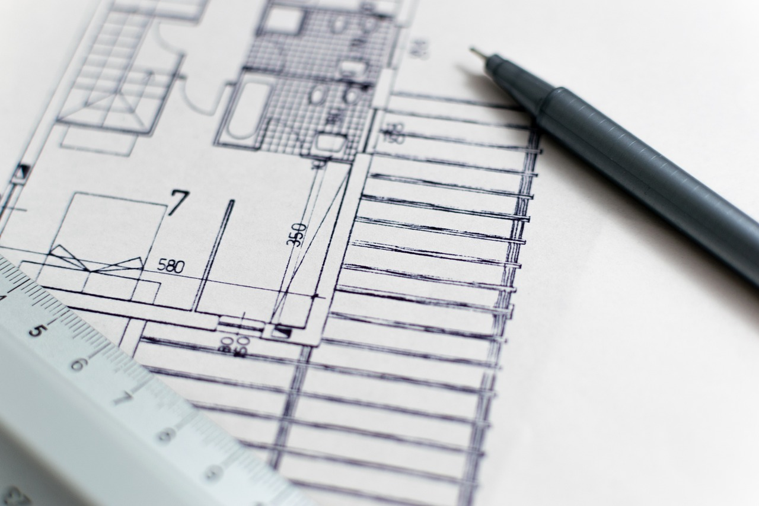

Fig 1. Pixabay (n.d.) Technical drawing

## Drawing scale

Drawing to scale means proportionally reducing the size of objects to fit them on a drawing sheet. It's like creating a miniature, accurate representation of the real-life design3. The scale used depends on the size of the object and the drawing sheet, with 1:50 and 1:20 being common in interior design

Below, you’ll find examples of some of the conventions and standards applicable to any interior design practice. For instance, a scale of 1:50 means every 1 unit on the drawing represents 50 units in reality3. This ensures all elements are in proportion to each other. Different types of drawings require different scales to effectively convey information:

* **Site plans**, which show the entire property, are often drawn at smaller scales like 1:100 or 1:250 to fit the entire area on the sheet
* **Floor plans**, detailing the layout of a specific floor, are typically drawn at 1:20 or 1:50.
* **Elevations**, which depict the vertical faces of walls, also use scales of 1:20 or 1:50 to show details like windows, doors, and wall finishes.
* **Sections**, which are cut-away views of a building or object, use the same scales as floor plans and elevations, allowing for a detailed look at the construction and internal components.
* **Details**, focusing on specific elements, might use larger scales like 1:10 or even 1:5 to show intricate features.
* **Lighting and electrical plans**, illustrating the placement of electrical fixtures and wiring, generally use 1:20 or 1:50 for clarity.

## Types of Technical Drawings and their applications:

Technical drawings come in various types, each serving a specific purpose in conveying information about the design:

○ **Floor Plans:** These overhead views show the layout of a space, including wall thickness, placement of doors and windows, and other key features22. They are essential for understanding the flow of movement within a space and planning the placement of furniture and fixtures.

○ **Reflected Ceiling Plans (RCPs):** RCPs focus on the ceiling, detailing the location of light fixtures, ceiling heights, HVAC vents, and other ceiling-mounted elements. They are crucial for coordinating the design of the ceiling and ensuring all necessary services are accounted for.

○ **Elevations:** Elevations depict a flat view of a wall, showing its height, openings (doors and windows), and any wall-mounted features. They are essential for understanding the vertical proportions of a space and planning the design of wall surfaces.

○ **Furniture Design Drawings:** These specialized drawings focus on custom-made furniture pieces, providing detailed information for their construction. They often include plans, elevations, sections, and details showing joinery, materials, and dimensions.

## Drawing sheet organisation for Effective Presentation

A well-organized drawing sheet ensures the information is presented clearly and logically. Key elements include:

○ **Sheet Border:** A border frames the drawing area, typically drawn 1cm or 10mm from the edge of the sheet5. It helps visually define the drawing space and provides a neat, professional appearance.

○ **Title Panel:** This section, usually located on the right side of the sheet, contains vital information about the drawing. It acts like an identification card, ensuring anyone looking at the drawing knows its purpose, context, and who created it. Key information in the title panel includes:

* **Drawing Name:** This clearly identifies the type of drawing, such as "Master Bedroom Floor Plan".
* **Drawing Number:** Essential for project management and cross-referencing, it helps organize the set of drawings for a project.
* **Date:** Records when the drawing was created, important for tracking revisions and ensuring everyone is working with the latest version
* **Scale:** Clearly indicates the scale used in the drawing, like "1:50 @ A3".
* **Client:** Provides details about the client, including their name and contact information.
* **Designer:** Identifies the individual or design firm responsible for creating the drawing.

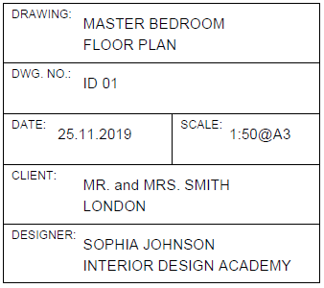

Fig 7. Example of a completed title panel

○ **Legend:** When a drawing uses symbols or abbreviations, a legend above the title panel provides a key to understanding their meaning. It acts as a visual dictionary, ensuring everyone interprets the symbols correctly.

○ **Drawing Sheet Composition:** The layout of the drawing area itself also requires careful consideration, particularly when multiple drawings are on a single sheet. It's essential to prioritize the most important drawing by placing it in the top left corner, ensuring it catches the viewer's attention first10. Maintaining equal spacing between drawings, and allocating enough room for annotations and dimensions, contributes to a visually appealing and easy-to-read layout.

## Effective Communication with Abbreviations and Symbols:

To streamline information and make drawings more concise, technical drawings utilize standard abbreviations and symbols. This shared language helps professionals across different disciplines quickly grasp the meaning of elements in the drawing without needing extensive written explanations. Some common examples include:

**○ Abbreviations:** "CH" for ceiling height, "D" for door, "DIA" for diameter. These shorthand notations save space and make the drawing less cluttered. However, it is important to keep in mind that following ISO regulations, not all of these are included in Technical Drawings, per se.

○ **Symbols:** Symbols are used to represent certain details in a technical drawing, in order to show them as detailed and consistent as possible. Symbols are used for details such as sockets, switch plates, TV aerials, phone lines, different types of lighting etc. Here are a few examples: A north arrow to indicate direction on a floor plan, tags to label doors and windows, symbols for different types of doors and windows in plan and elevation views. These symbols visually represent elements, making them instantly recognizable on the drawing.

## Line Types

## Different line types convey specific information in a technical drawing, acting as visual cues to guide the viewer's understanding. They help distinguish between different elements and clarify the relationships between them. Common line types include:

○ **Construction Line:** A light, temporary line used for initial sketching and layout. They're typically erased once the final lines are in place.

○ **Drawing Line:** A heavier, permanent line used to define the visible outlines of objects and structures in the drawing

○ **Break-Line:** Used to indicate that a portion of an object is not shown in the drawing, often to save space or simplify a complex view.

○ **Hidden Line:** Depicted as a dashed line, it represents edges or features that are hidden from view in the current drawing but exist in the actual object.

○ **Center Line:** A thin line with alternating long and short dashes, used to mark the center of circles, arcs, and symmetrical objects.

○ **Dimension Line:** A thin line with arrowheads at each end, used to indicate the distance between two points.

○ **Leader Line:** A thin line with an arrowhead at one end, used to connect a note or dimension to a specific feature on the drawing.

○ **Cutting Plane:** A thick line indicating where an imaginary cut is made to create a sectional view.

## Hatching

## Hatching patterns, which are repeated lines or symbols, are used to visually represent different materials in section drawings. This convention allows viewers to quickly understand the construction of an object or building without needing extensive written descriptions.

## Dimensions (Dimension Lines)

Dimensions provide precise measurements of objects and spaces in a technical drawing17. This is crucial for ensuring the design can be accurately built or manufactured.

○ **Dimension Lines and Leader Lines:** Dimension lines, with perpendicular leader lines at each end, clearly indicate what is being measured. Architectural ticks, small diagonal lines, mark the start and end points of these dimension lines, providing a standardized way to represent measurements.

○ **Standard Units and Placement:** The standard unit of measurement in technical drawings is millimeters, ensuring consistency. Dimensions are typically placed above the dimension lines for clarity.

○ **Hierarchy for Clarity:** When multiple dimensions are needed, a hierarchy is used to ensure the drawing remains readable. Overall dimensions are placed furthest out, followed by more detailed breakdowns of individual elements below. This hierarchical approach prevents clutter and helps viewers understand the relationships between different measurements.

**Special Cases: Angled and Curved Dimensions:**

○ **Angled Dimensions:** Angled dimensions require a slightly different approach, using hidden lines to represent vertical and horizontal measurements and including the angle measurement itself.

○ **Curved or Circular Dimensions:** These are represented by dimension lines following the curve of the object, accompanied by locational dimensions and the radius measurement.

## Lettering

**Lettering for Clear Communication:** Clear and legible lettering is essential for annotations, dimensions, and labels within a technical drawing.

○ **Neatness and Legibility:** Using a pencil guideline helps achieve neat and consistent lettering21. Capital letters are the standard for technical drawings, ensuring clarity and uniformity.

○ **Inking for Permanence:** Inking the lettering after drawing in pencil makes it permanent and easier to read, particularly on printed copies.

**Mastery of technical drawing theory is essential for effective communication in design fields.** The use of standardized conventions ensures clarity, accuracy, and consistency in conveying design intent, fostering collaboration among professionals from various disciplines. **By understanding the principles of scale, line types, symbols, dimensioning, and lettering, designers can create comprehensive drawings that serve as the foundation for successful project execution.** Whether crafted manually or digitally, these drawings act as a universal language, bridging the gap between creative vision and practical realization

|  |  |
| --- | --- |
|  |  |
|  |  |
|  |  |
|  |  |
|  |  |
|  |  |

Fig 2. Pixabay (n.d.) Example of tools required for drawing

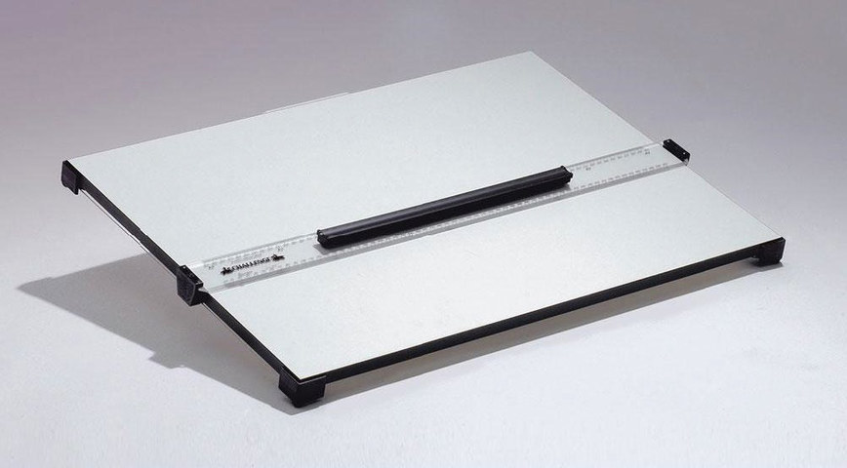

Fig 3. Blundell Harding (2020) *Challenge Drawing Board* [photograph]

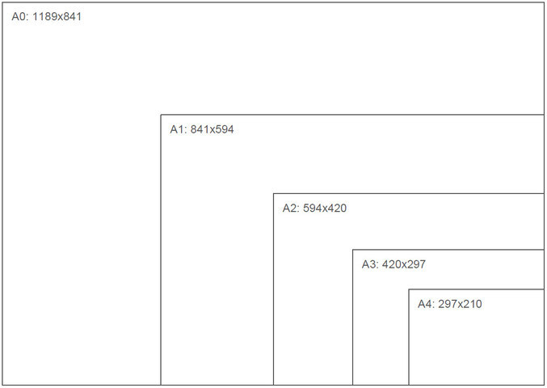

Fig 4. Paper sizes A4 – A0



Fig 5. Pixabay (n.d.) Clutch pencil

Fig 6. Drawing sheet and allocation of space for a title panel and legend

Fig 7. Example of a completed title panel

#### DRAWING SHEET COMPOSITION

The position of the title panel can change depending on the amount of space available on the sheet. The most common format is where the title panel and legend are positioned on the right-hand side of the sheet.

Once the sheet border and title panel are drawn, the main drawing element can be created. Determine a centre point by drawing a diagonal line from each top corner of the drawing area to the bottom corner. Note: Each diagonal line should be drawn using a light pencil that can be erased later.

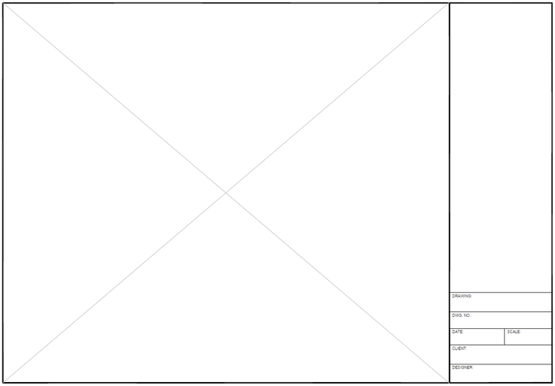

Fig 8. The centre point of the drawing area indicated

Next, position the drawing by taking the overall length and width of the floor plan or elevation. In the example (Fig. 8), the floor plan is drawn at a 1:50 scale, and the overall length of the room is 5500mm. Using the scale ruler, position 2250mm on the centre point and draw a horizontal line from 0-5500mm. Alternatively, mark the start and end points.

The overall width of the room is 4000mm. Use the scale ruler to position 2000mm on the centre point and draw a vertical line from 0-4000mm, or alternatively, simply mark the start and end points.

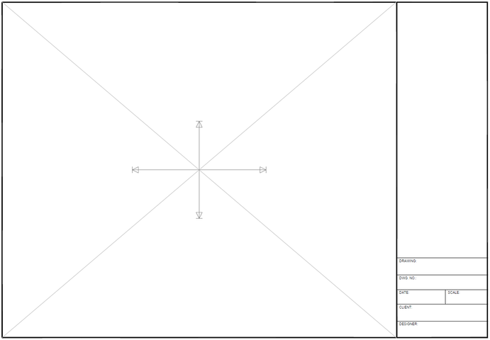

Fig 9. Horizontal and vertical lines measured and drawn from the centre point

Next, draw the outline of the space. Using the set square, draw each vertical line through the endpoints on the horizontal axis and then use the parallel bar to draw each horizontal line through the endpoints on the vertical axis. The lines should join to form a rectangular shape that provides the basic outline for the floor plan drawing.

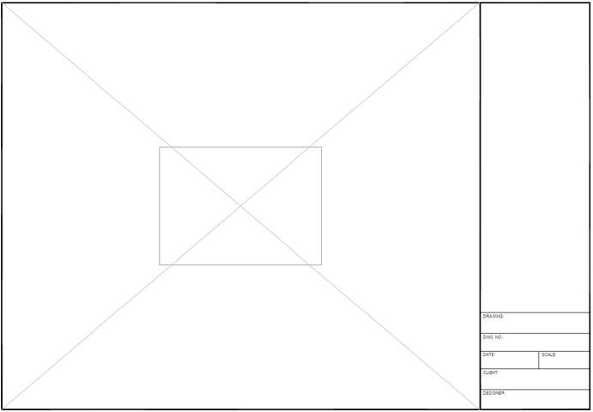

Fig 10. The outline for the floor plan

If using a larger drawing sheet, you might be able to put more than one drawing on the same sheet, but you must carefully consider its composition. Locate the drawing with the greatest priority towards the top left corner of the drawing sheet.

Whatever arrangement you choose, it is essential to maintain equal spacing between each drawing. Remember to allocate enough space for annotations and dimension details.

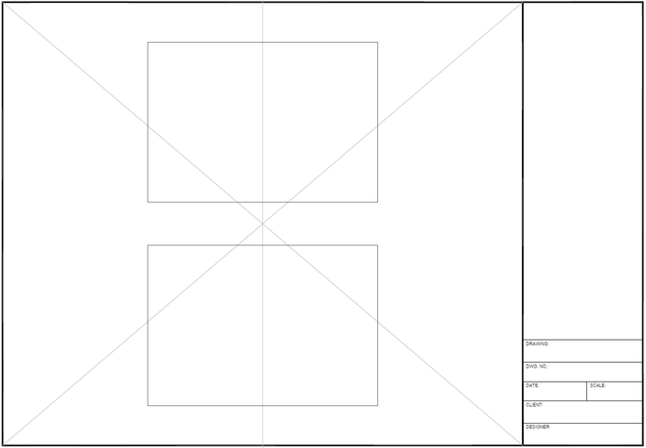

Fig 11 (a). Different compositions for a drawing sheet

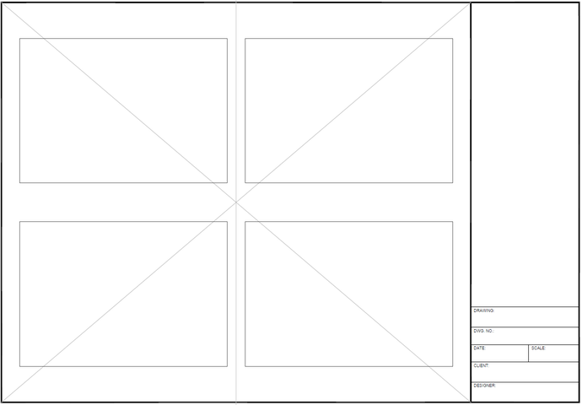

Fig 11 (b). Different compositions for a drawing sheet

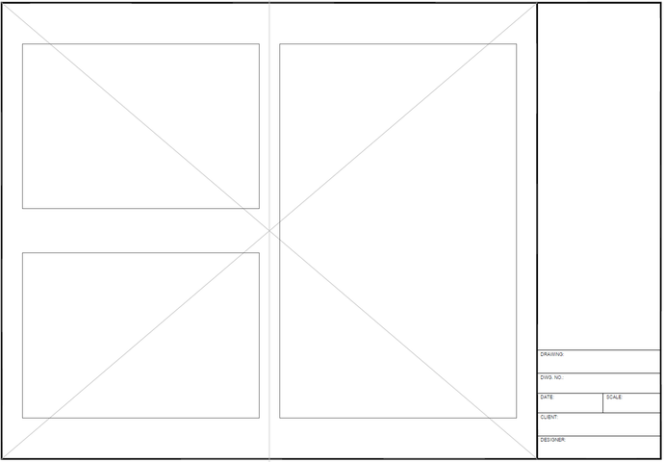

Fig 11 (c). Different compositions for a drawing sheet

## Adding a Legend to your Technical Drawing

In Technical Drawings, we use a legend in order to explain the various symbols we are using and the meaning of each one. They type of symbol used will depend on the nature of the Technical Drawing and the scope and purpose of it. For example, in a Lighting Plan, the symbols explained and included in the Leged will refer to the electrical symbols used on the Technical Drawing.

(Add example of Technical Drawing with Legend)

## 

## 

## Abbreviations and symbols

Technical drawings use standard abbreviations and symbols. Here are some of the common abbreviations and symbols used on technical drawings.

| **Abbreviation** | **Meaning** | **Abbreviation** | **Meaning** |
| --- | --- | --- | --- |
| CH | ceiling height | HW | hot water unit |
| D | door | INSUL | insulation |
| DG | double glazing | M | metre |
| DIA | diameter | MSB | master switch board |
| DIM | dimension | SD | sliding door |
| DWG | drawing | SHR | shower |
| EL | elevation | TEL | telephone |
| FA | floor area | TV | television |
| FP | floor plan | VENT | ventilation |
| FFL | finished floor level | VP | vent pipe |
| GL | glass | W | window |
| GM | gas metre | WC | water closet |
| HTR | heater | WR | wardrobe |

**North point:** placed at the top right-hand corner of the drawing area on a technical floor plan drawing. The arrow of the north point



Fig 12. North arrow

**Door and window tag:** a reference for a specific door or window on a technical floor plan drawing. The top line references a given door or window and the number allocated to the specific one (i.e. D01 and W01). The first measurement under each is the distance from the floor to the **bottom** of the door or window, and the second is the distance from the floor to the top.

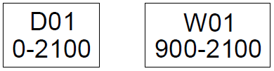

Fig 11. Tag

## Door symbols

The correct door symbol should be drawn for technical plans and elevation drawings. If a door is hinged, it is represented in an open position on a floor plan and with a dashed line on an elevation. Here are some of the most common types of door symbols used in plan and elevation views:

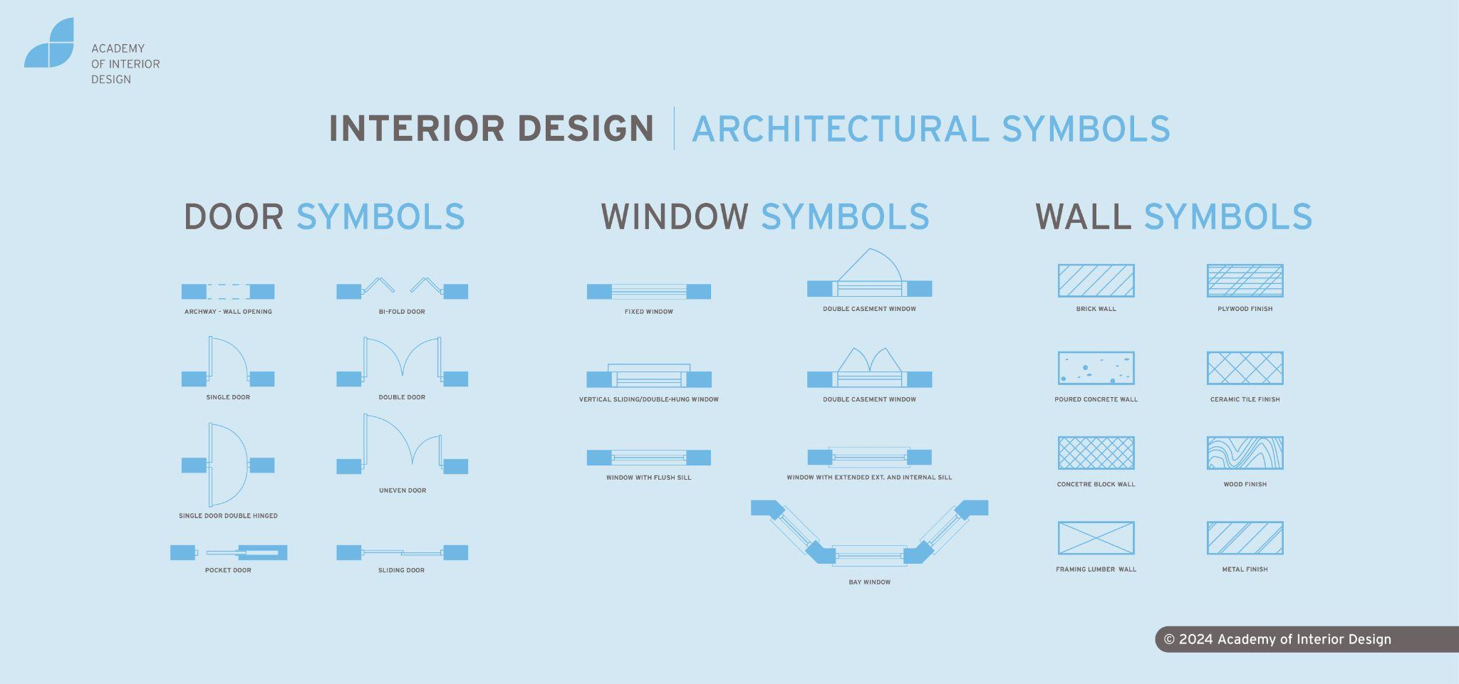

Fig 12. Doors in plan view

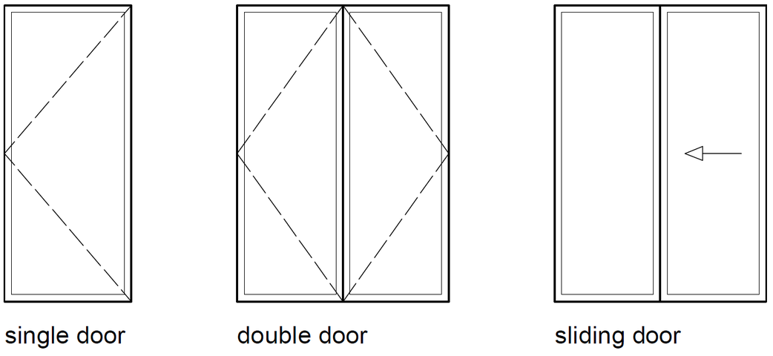

Fig 13. Doors in elevation view

## Window symbols

The correct window symbol should be drawn for both a technical plan and elevation drawing. The outline of the frame and the glazing are illustrated both on a floor plan and elevation. Here are some of the most common types of window symbols used in plan and elevation views:

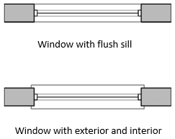

Fig 14 (a). Windows in plan view

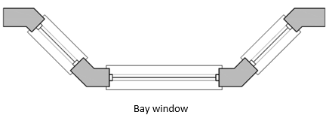

Fig 14 (b). Windows in plan view



Fig 14 (c). Windows in plan view

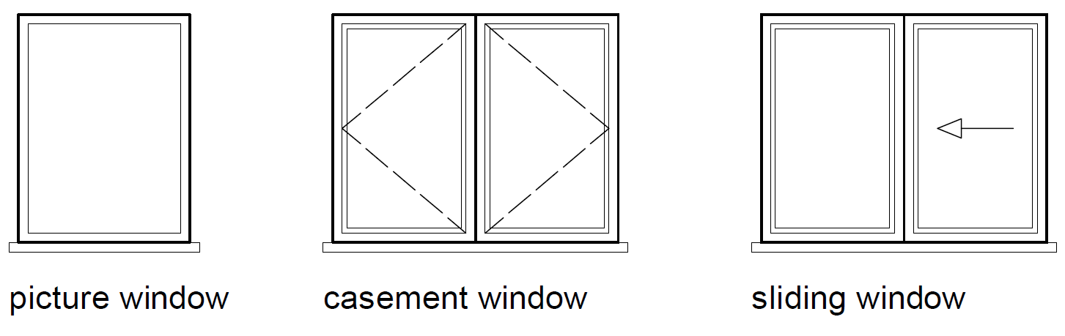

Fig 15. Windows in elevation view

## Line symbols

Different line types can convey a variety of information within a technical drawing. Here are the most common line types:

* **Construction line:** light line for marking the outline of the drawing. It is usually drawn with a light pencil that is erased later
* **Drawing line:** heavier line for inking in the drawing
* **Break-line:** medium line used when only a part of the drawing is shown, or the extent of the whole drawing would go beyond the paper size used
* **Hidden line:** light line demoting something overhead on a plan (e.g. an arch or a beam) and also used if an object is hidden by another object
* **Centre line:** light line illustrating the centre of an object or drawing
* **Dimension line:** light line used to record dimensional information
* **Leader line:** another light line drawn to highlight something specific on the drawing
* **Cutting plane:** heavier line indicating a section cut through the plan. They are accompanied by a section drawing, showing the way the item has been cut and the details within the cut.

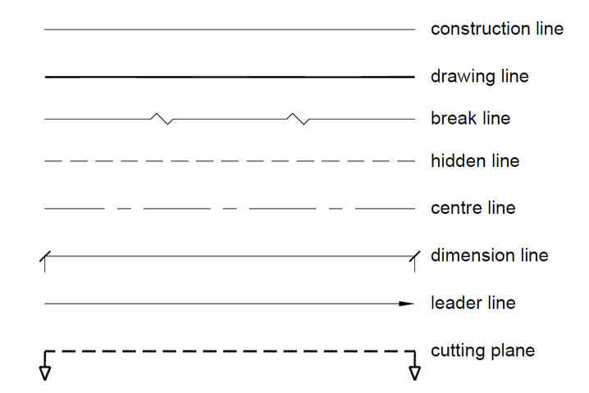

Fig 16. Line types used for technical drawing

## Hatching

You should represent each material cut in a technical floor plan or section drawing with a standard hatch or symbol. Here is a list of the most common hatching used for technical drawing:

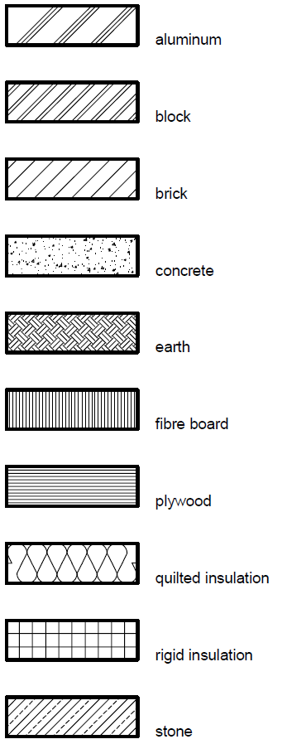

Fig 17. Hatching symbols used for technical drawing

## Dimensioning

Dimensional detail is included in each type of technical drawing to ensure that the information on the drawing can be read faster. Dimensional information eliminates the need for everyone involved in the project to measure each drawing line. In turn, the inclusion of dimensional detail prevents errors regarding sizing.

The **dimension line** consists of a straight line with a perpendicular line (i.e. a **leader line** drawn at either end). The dimension line should be drawn parallel to whatever the measurement is referencing, and the leader line should be drawn perpendicular to the dimension line. The dimensional and the leader lines are drawn using the same pen nib size. In addition, the dimensional and the leader lines should meet, but the leader line should not touch the drawing itself.

The start and end points of the dimension line in Interior Design and Architecture are shown usingan architectural tick. The most common are shown in Fig 18. Closed arrows are usually used in the engineering industry.

For a technical drawing, the standard unit of measurement is a millimetre. The size is most commonly written above the dimension line.

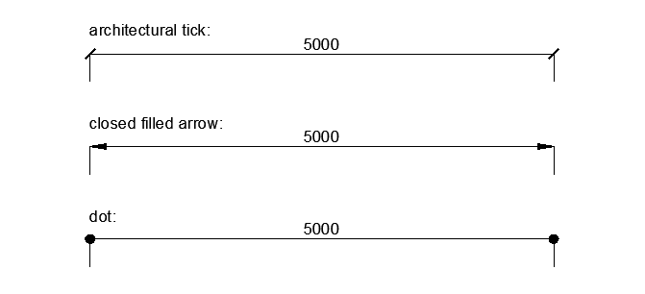

Fig 18. Arrows used for technical drawing

## 

## Hierarchy of dimension placement

In interior design, the dimensional detail for the internal space of a room must be recorded on a technical floor plan drawing. At a minimum, note the overall length of each main structural element. If there are no features or openings in a wall, then record the overall length. However, if there is a feature or opening (e.g. chimney breast or window), then the length of each element should also be recorded.

If more than one overall dimension line is required, then a hierarchy of dimensional placement should be implemented. Note the overall length furthest out from the technical floor plan drawing and then place a more detailed breakdown below the overall length, as illustrated in Fig. 19 and Fig. 20.

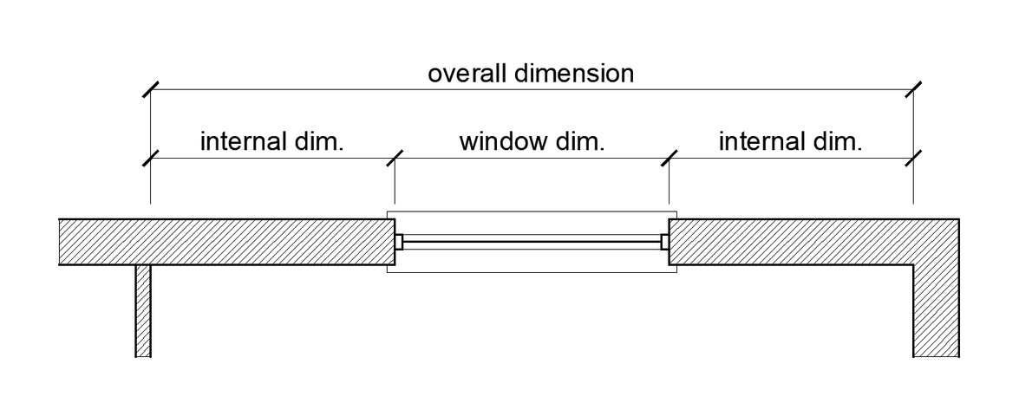

Fig 19. Hierarchy of dimensional placement explained

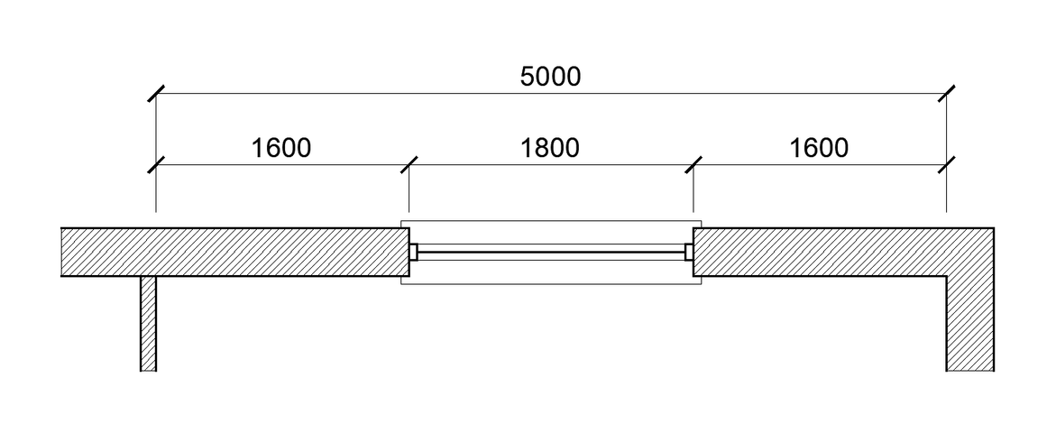

Fig 20. Hierarchy of dimensional placement

Note: The same principle applies to a technical elevation drawing where each height measurement should be recorded.

#### ANGLED DIMENSIONS

For an angular dimension, it is best practice to record the vertical and horizontal measurements using a hidden line. The angular measurement should also be shown.

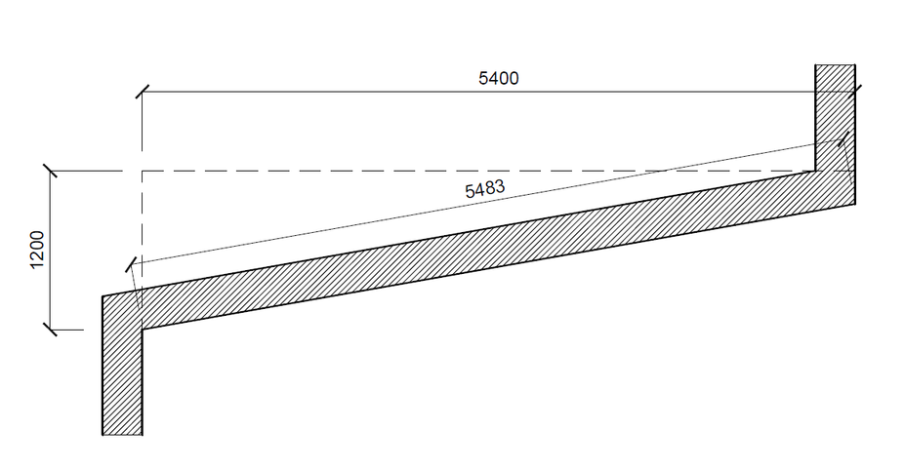

Fig 21. Angular dimension

### 

#### CURVED OR CIRCULAR DIMENSIONS

To represent a curved flooring pattern or a curved window, record a curved dimension as shown in Fig 22. In addition, record the location information with the actual curve or circle measurement.

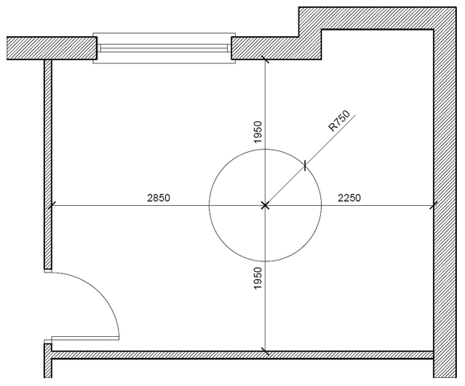

Fig 22. Circular shape including locational dimensions and radius measurement

## 

## Lettering

For each technical drawing, add text to the title panel and legend and annotations and dimensional information to the drawing itself. Both the hand-written lettering and numbering must be legible as misinterpretation of information can lead to costly mistakes being made on a design project.

Draw a guideline in pencil to achieve neat and precise lettering on a manually-produced drawing. A light pencil guide can ensure that the lettering is uniform. Next, write the text in capital lettering using a pencil. Then ink and erase all pencil marks.

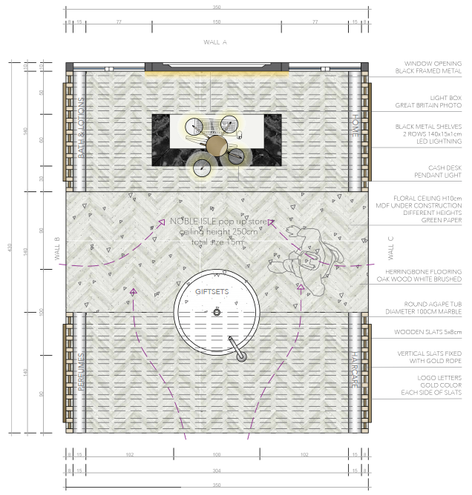

Fig 23. Layout plan – student example with annotations and dimensional details

## Types of Technical Drawings:FLOOR PLANS

As we have learnt from previous assignments, interior designers would create floor plans to communicate technical details such as the lengths and widths of a space. Floor plans are 2-dimensional technical drawings which do not show any depth. Technical floor plans are drawn to scale and are used to represent a view from above looking down into the space. You will note within floor plans, we are able to see the thickness of walls, the placement of windows, doors, fireplaces etc. Basic drawing conventions are applied, and drawing tools are used to ensure a neat, precise drawing which communicates valuable information about the technical details of the space.

When drawing the floor plan, we need to imagine the space sliced half horizontally, about 1m above the bottom of the floor line. This now will reveal the floor plan. As seen in the below example, if we imagine this space has been sliced in half at 1m above the floor level, we can see that we would cut through solid walls and doors and windows. We use the door and wall symbols as previously discussed to show the “cut” through door openings and window openings.

Floor plans can communicate the existing space (as-built drawings). We can also plan the space and positioning of furniture (furniture layouts), specify flooring (floor finish layouts), and communicate other interior design elements. A floor plan is thus a vital tool to use when sharing your designs.

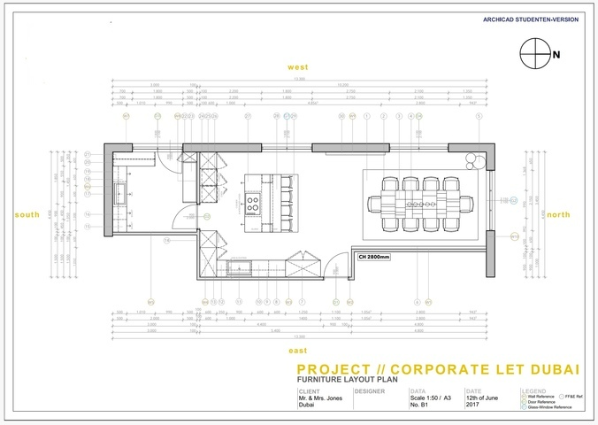

Fig 24. Example of a floor plan

**Important tips to keep in mind when drawing a floor plan:**

* Use an appropriate choice of drawing sheet size depending on the chosen scale of the drawing
* Use an appropriate scale – make sure you have space for your dimensions and title block
* Include a neat border and title panel with the required information
* Include a north point, typically positioned in the top right-hand corner of the drawing. A north point aids in communicating the direction of North in relation to our space. This is useful to know as it helps us understand where light enters a space, for example
* Each wall should receive a well tag (e.g. A and B). This helps us cross-reference with elevations so we understand which elevation matches each wall on the floor plan
* Make sure to show all window and door openings using the correct symbols
* Don’t forget all relevant dimensional information; both smaller detailed dimensions and overall dimensions are important
* Once you have finished drawing in pencil, and are happy with the final drawing, be sure to ink in the floor plan using a pen. Don’t forget to work with the correct line weights allocated to each element
* A wall hatch should be added
* Each window and door should be numbered correctly (e.g. D01: 0-2100)
* Include the name of the room and ceiling height noted underneath the floor plan drawing for a clean, uncluttered finish

#### Ceiling components and reflected ceiling plans

A Reflected Ceiling Plan, also named as (RCP), is a technical drawing that shows the items located on a ceiling of a space/room.

Common information included in RCPs is:

* Ceiling heights
* Specification on the type of ceiling (conventional, suspended, etc.)
* Specification for the ceiling finishes
* Lighting locations and their types
* Bulkheads, Beams or any decorative and structural features that result in ceiling height changes
* Heating Ventilation and Air Conditioning (HVAC) supply and return air vents
* Duct locations and heights were visible.
* Security systems, including alarms, sprinklers, sensors, security camera locations and security monitors.

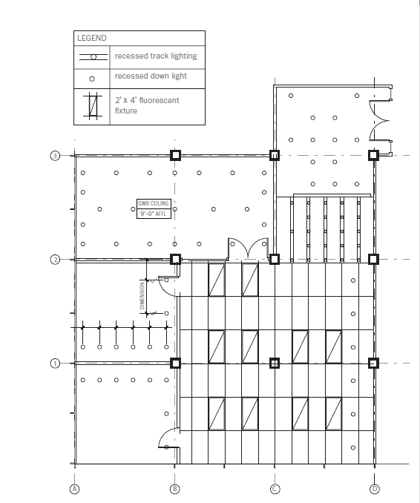

Fig. 25 Grimley, Chris, and Mimi Love (2007) Reflected Ceiling plans [digital image]

**Note:** *Mind the difference between reflected ceiling plans and electrical plans. RCP will only show information related to or included within the ceiling structure, while an electrical plan will show every electrical feature of the room, whether connected to the ceiling, walls or flooring.*

### ELEVATIONS

As we learned from previous assignments, technical elevations are 2D dimensional drawings communicating essential information, such as the heights within a space. These drawings are drawn to scale and represent the interior wall surface or exterior façade. An elevation is a flat 2D representation of what one sees when looking at a particular wall. An elevation can communicate details of windows, doors, fireplaces, etc., clearly. Basic drawing conventions are applied, and drawing tools are used to ensure a neat, precise drawing which communicates valuable information about the technical details of the wall surface.

Unlike the floor plan, a horizontal cut through the space, elevations communicate a particular wall surface. The elevations allow us to measure and specify items on the walls or within 1m of each wall shown. We can establish window and door measurements and show the location of pictures, sofas, chairs, lighting and other items positioned on that particular surface where required. We could also use an elevation to communicate a particular painted design or specific wall finish.

In the below example, you will note furniture has been included, and although the bed would extend beyond the 1m limit, it would not make sense to “cut” this bed in half at 1m from the wall, so here, the entire bed is shown as this makes more sense.

If you are only communicating the wall finishes of the space, there would be no need to show the furniture.

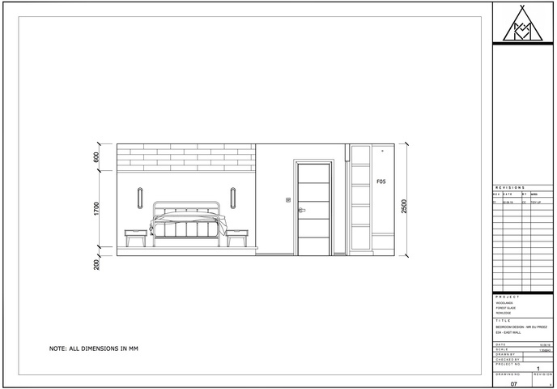

Fig 26. Example showing an elevation which includes furniture

**Important tips to keep in mind when drawing an elevation:**

* Use an appropriate choice of drawing sheet size depending on the chosen scale of the drawing
* Use an appropriate scale – make sure you have space for your dimensions and title block
* Include a neat border and title panel with the required information
* Each wall should receive a well tag (e.g. A and B). This helps us cross-reference with elevations so we understand which elevation matches each wall on the floor plan
* Make sure to include all windows, doors, electrical sockets and/or switches present on the elevation as we see them
* Don’t forget all relevant dimensional information; both smaller detailed dimensions and overall dimensions are important. Remember, an elevation should focus on including only vertical height dimensions. Only include length dimensions of finer details that you are not able to place on the floor plan
* Once you have finished drawing in pencil, and are happy with the final drawing, be sure to ink in the elevation using a pen. Don’t forget to work with the correct line weights allocated to each element
* Where necessary, you may need to include annotations with a leader line to identify everything on the drawing if required
* Include dashed lines to represent the way a window/door will open
* Levels can be indicated where relevant
* Grid or section line indicated where needed
* Note: no depth should be shown on a technical elevation drawing

### Furniture Design

Furniture Design refers to any custom-made interior furnishes tailored to the needs of your design. This refers to any piece of work, whether it is large or small, that is fabricated for a specific project/room. This can include shelving systems, staircases, custom kitchen cabinets, etc. These can be produced using various materials, such as wood steel, aluminium etc.

Furniture Design is especially useful if you have a specific need or a uniquely shaped space that is not compatible with the standard off-the-shelf options. Furniture Design will, in this case, offer a more holistic approach to the design and allow you to maximise the space.

Depending on the design and nature of your project, the Technical drawings of furniture should include the minimum of:

* A plan of the customized piece
* All elevations of the piece
* Sections showing the interior features (i.e. the interior shelving/compartments)
* Details of the piece to ensure its good manufacturing. These can include the opening systems, the junction at the corners, upholstering details, etc;
* A complete legend referring to all materials to be used and their location within the design piece (ie. specifications)
* All relevant dimensions

Below you will find some examples of technical drawings for custom joinery.

Fig .27. BAID, Drawings for custom-made display unit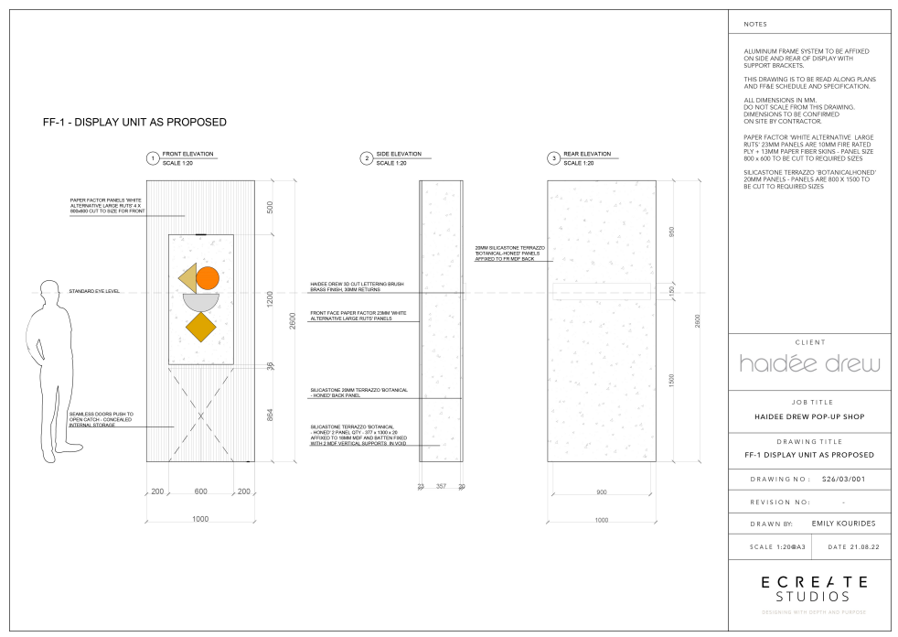

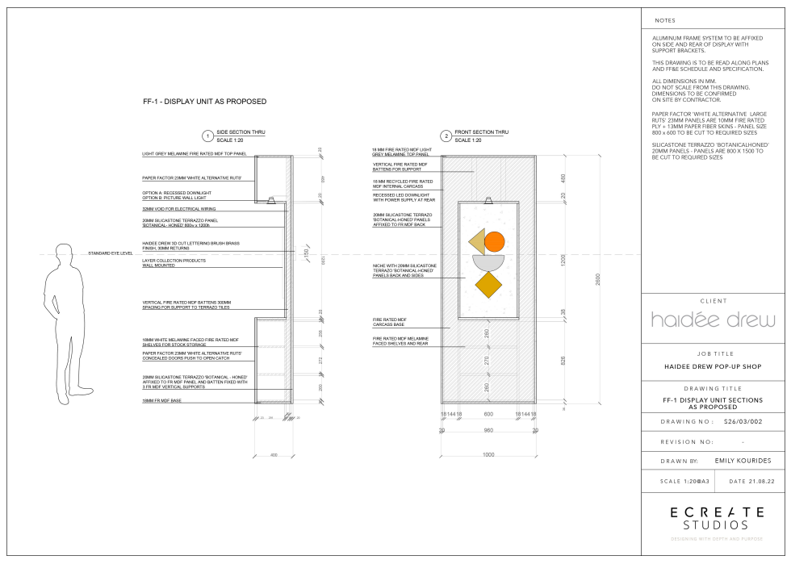

Fig .28 BAID, Drawings for custom-made display unit

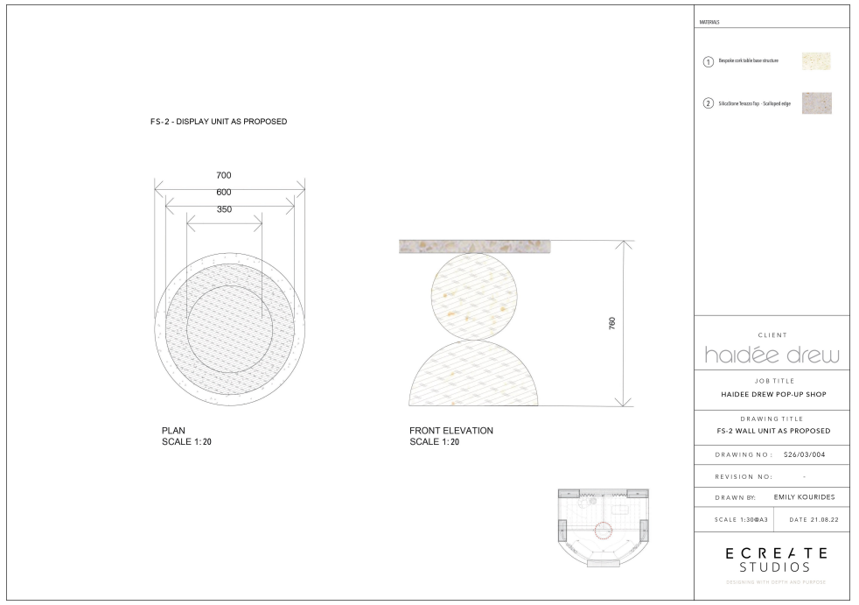

Fig .29 BAID, Drawings for custom-made display unit

To conclude, it is important to understand the significant role Technical Drawings play in an Interior design Project. Making sure you have a solid understanding of the types of Technical Drawings, will assist in understanding which ones are necessary for the Project you are working on, in order to provide the appropriate information for all the stakeholders of the project.